***Power BI & Tableau***

Assignment 1

1. Image of report view page

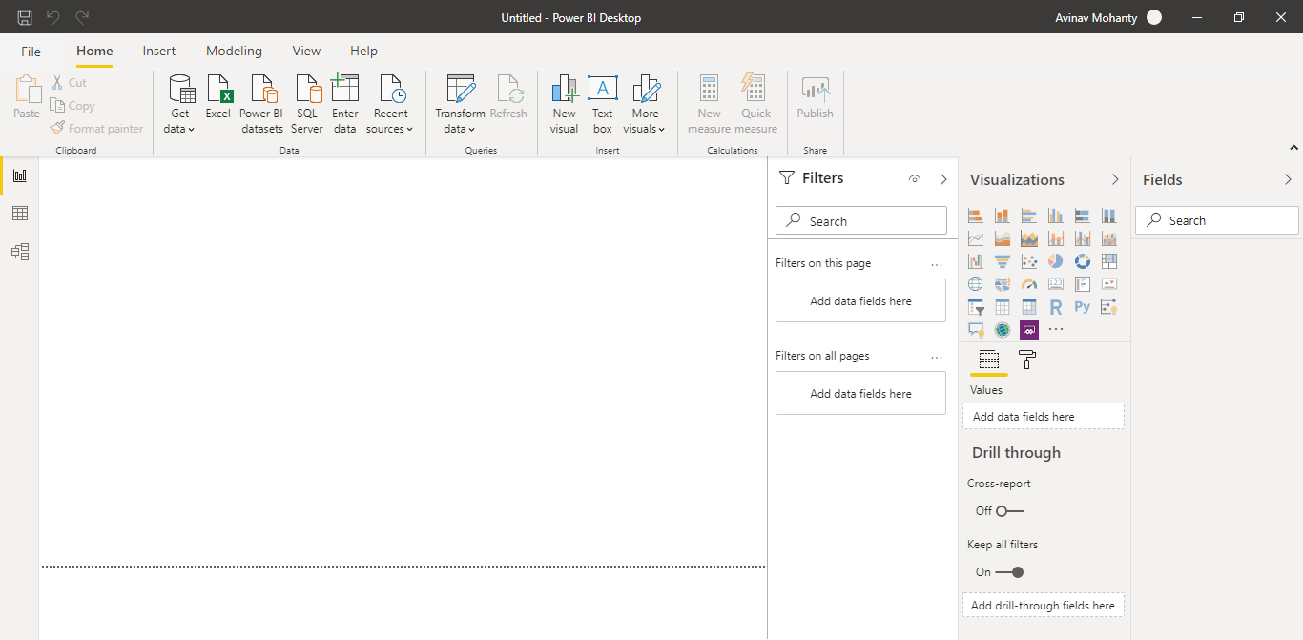

* Document with following screenshot below

1. Report view



1. Data view

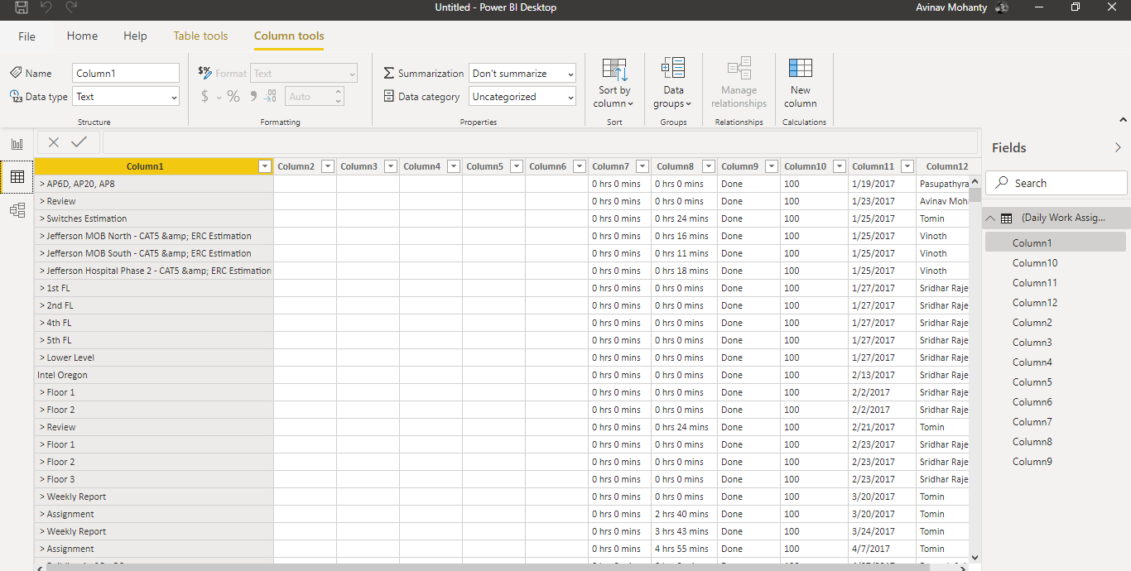

1. Model view

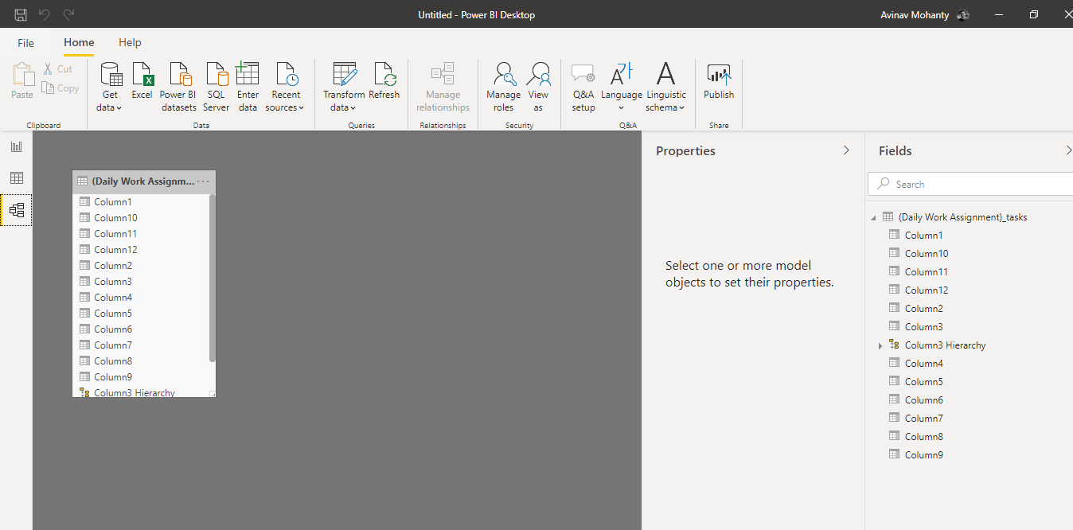

1. Power query editor

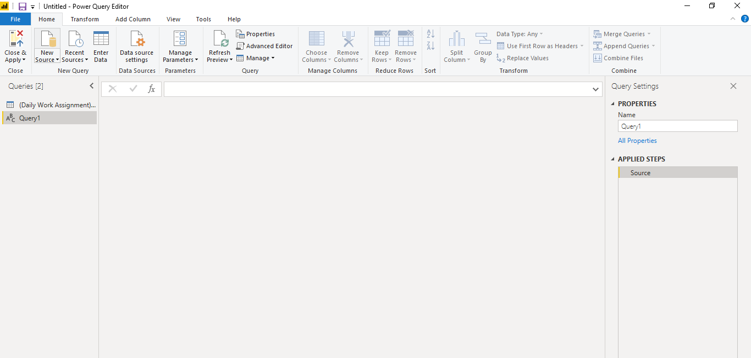

1. Advance editor

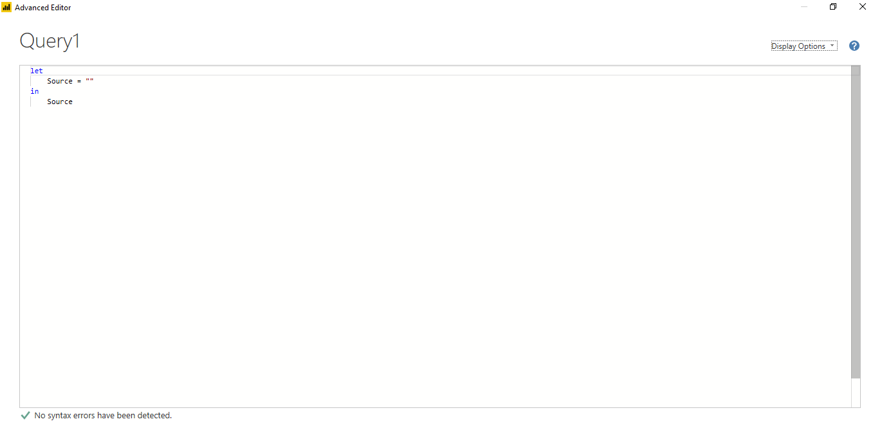

* Document preparation along with the pricing

|  |  |
| --- | --- |
| Power BI Desktop | free |
| Power BI Pro | 9.99/month |
| Power BI Premium | 4995/month |